**LINN Terminal Management System**

**Brochure**

March 2021

**History of document changes:**

|  |  |  |  |
| --- | --- | --- | --- |
| Version | Date | Editor | Description |
| 1.0 | 05.02.2021 | Dusan Ciric, MScEE  Vladan Cvejic, MScEE | Initial version |
|  |  |  |  |
|  |  |  |  |

|  |  |
| --- | --- |
| Ponuda: | Ponuda – Nadgradnja MES sistema na Autopunilištu |
| Datum: | 23.02.2021 |
| Naš referentni broj: | PK-21-3018-0003 |
| Vaš referentni broj |  |
| Revizija: | 2 |

Content:

1 Uvod 6

1.1.1 MES – nova logička arhitektura 9

# Uvod

Na Sl. 1-1 je blokovski prilaz MES sistema u okruženju procesne opreme na terminalu sa kojim upravlja, kao i drugih učesnika u procesu (SAP, LIMS, …). Oprema koja je u MES ormanu u serverskoj sali auto pretakališta, označena je konturom, koja je prikazana i na Sl.1-2. MES se nalazi u središtu sistema upravljanja terminalima, između poslovnih i procesnih sistema.

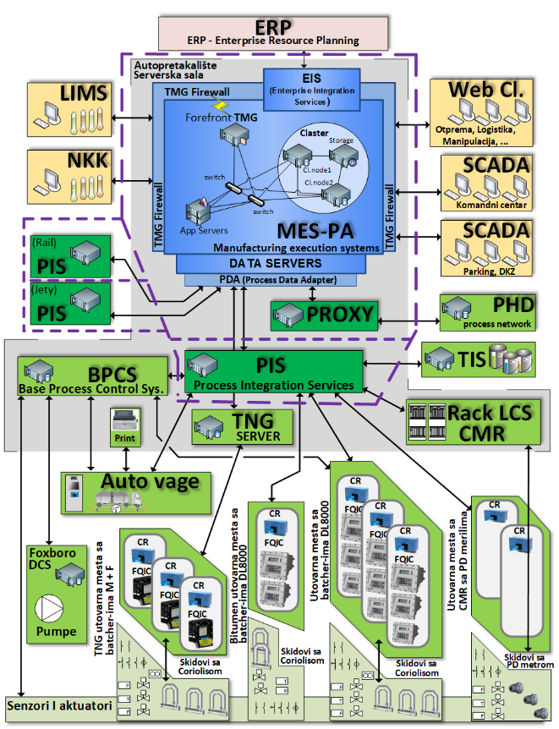

Sl. 1-1

• Korisnici MES-a: SAP, LIMS, NKK i sl. MES-u pristupaju preko TMG *Firewall*-a.

• Komunikacija MES-a sa procesnom upravljačko-signalno i mernom opremom je preko PIS servera (*Process Integration Services*) i BPCS-a.

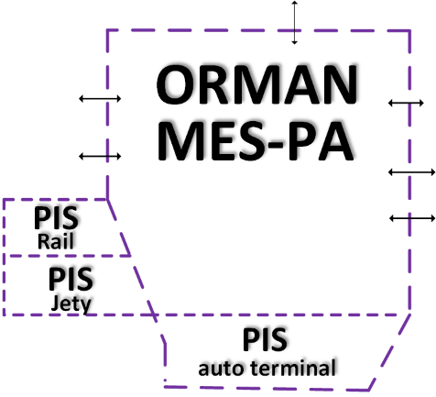Većina hardverskih komponenti je iz 2011. g., tako da se već duži period razmatra njihova zamena. Svesni složenosti Sistema, ENSACO je predložio realizaciju u više faza (07.11.2019.g., 28.12.2020.g.).

Zamena centralnog dela Sistema je najkompleksniji zadatak, a način rešavanja dat je u predlogu od 07.11.2019.g. i zasnovan je na savremenoj tehnologiji za klaster sisteme. Ovi radovi su predviđeni za poslednju fazu.

Sl. 1-2

S obzirom da ovom ponudom, na zahtev Korisnika Sistema, treba da se obuhvati promena gotovo svih komponenti, što uključuje i najvažnije delove (klaster), neophodno je sagledati postojeću HW-SW arhitekturu sistema i uticaj novih komponenti i sistemskih softvera na softversku arhitekturu MES-a.

**Tehnološki deo MES sistema**

* *MES- Technological Core* su fizički dva servera za redundantni LINN TMS. TMS-ovi su redundantno povezani sa gornjim nivoom posredstvom dva sviča, a sa opremom u polju, posredstvom postojećeg sviča ili sada dodatih rutera za potrebe povezivanja opreme iz drugih nezavisnih LAN-ova, koji imaju iste opsege IP adresa.
* *Procesni podsistemi*: PIS serveri (BPCS), upravljačko-merna oprema na skidovima, čitači kartica u saobraćaju, displeji, MES-HMI operaterski paneli u polju i sl.

Prethodno opisane promene u novoj arhitekturi na nivou TMG servera(firewall), klastera i procesnih servera, objedinjeno su prikazane na slici 2.3-2. Ovde je na jednom mestu vidljivo i povezivanje gotovo svih eksternih podsistema sa MES-om: Poslovni, preko firewall-a (Cisco redundantni ruteri), a Tehnološki podsistemi i merno-upravljačka oprema u polju, preko sviča na redundantni TMS.

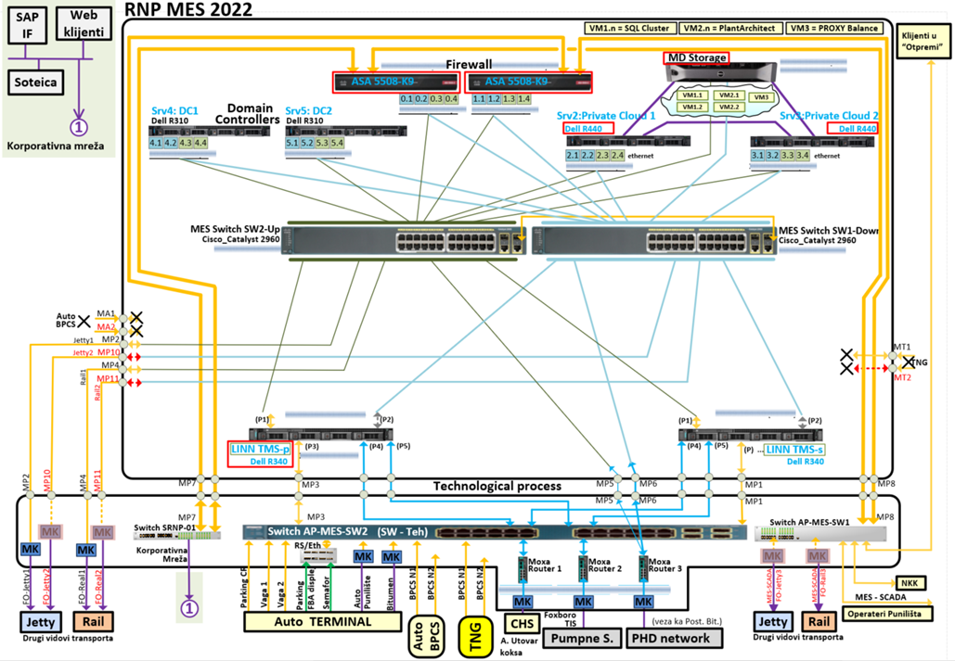

Sl.2.3-2

### MES – nova logička arhitektura

Kako je ranije opisano, MES je izmenio internu arhitekturu saglasno novom sistemskom okruženju, što je prikazano na Sl.2.3.2-1.

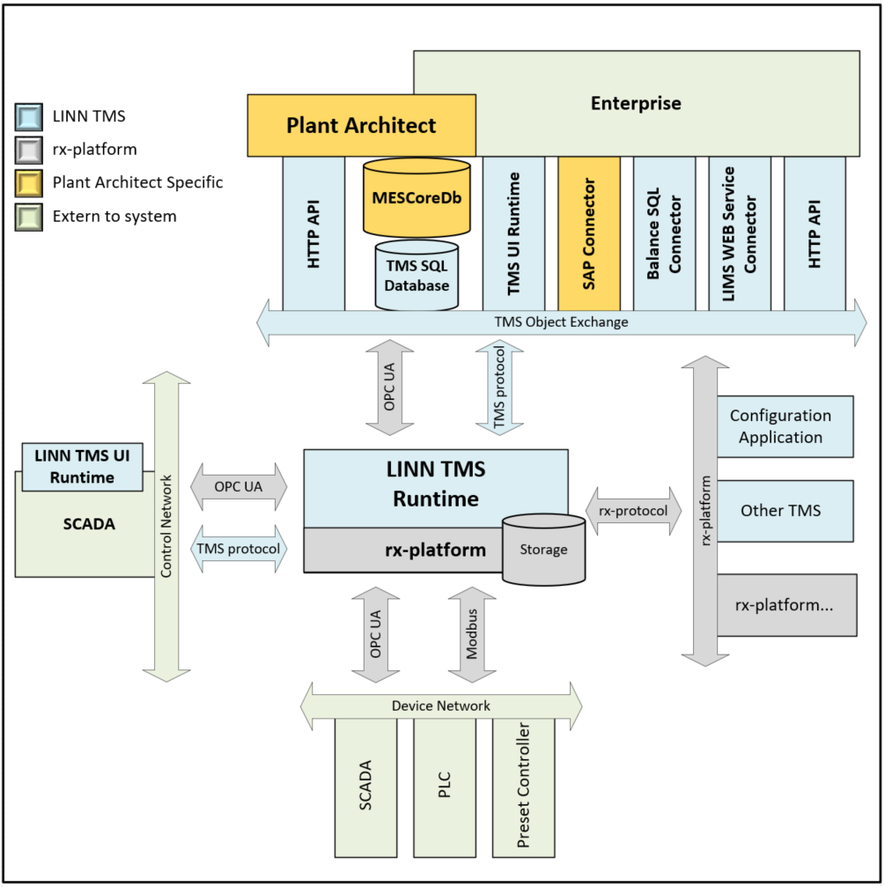

Sl.2.3.2-1

#### LINN TMS

LINN TMS is Edge Terminal Management System.

Features:

* Covers complete Terminal Management workflow process including Traffic, Scale, OCR, Batchers, etc.
* Inbuild configuration interface for additional customization of the system and equipment (parameters, custody-transfer, pumps, reservoirs…)
* Support for sample data entry and data manipulation retrieved from Laboratory Informational Management System
* peer-to-peer communication between multiple LINN TMS systems, while keeping configuration aspects of whole system as simple as possible. LIN TMS systems are independent from each other and yet functioning as one.
* Support of all market relevant interfaces (Microservices, MQTT, REST, JSON…)
* Support of major previous generation automation software interfaces (SQL DB, WEB Service…)
* Capability to be extended with Edge AI component for improving work efficiency and security
* Easy to handle user interface for System supervision and parametrization

LINN TMS is designed to provide clear split between Cloud and Edge technologies. Due to a reason of different dynamics related to the changes and development of industrial software compared to the business software systems, providing their independence is a must. Virtual isolation provides cost effectiveness and lower maintenance investment.

LINN TMS provides flexibility.

* It is stand-alone component
* Can be component of larges system – integrated component (for example, one measurement point of larger TMS system)

LINN TMS provides scalability:

* One scale without measurement points or
* Complex system with:
  + Measurement points,
  + Scales,
  + Pumps,
  + Reservoirs,
  + Parking lots
  + OCR, etc

LINN TMS can completely cover Terminal management workflow control. Also, it has capability to communicate with external systems using standard or vendor-specific connectors (SAP interface).

LINN TMS is based on ENSACO Solutions platform - RX–platform.

RX-platform is general-purpose Real-Time Database Management System with protocol framework and programming tools. It is basically distributed platform for building applications that exchange Real-Time data.

RX-platform is implementing hierarchy of Classes. These classes are key enablers for creation of higher-level applications. RX-platform enables programmers to directly use it for Edge IoT and Industrial IoT applications, custom applications such as Warehouse Management System, complex systems that include Operations Technologies such as Manufacturing Execution System (MES) or any other application that need to rely on Real-Time data. RX-platform is Industry 4.0 ready.

RX platform enables and manages connectivity to devices, databases, file systems etc. It incorporates OPC UA communication protocol and it is prepared to be extended with additional communication, historian, security and soft plc modules. In that way it consists building blocks for scalable industry automation solution.

RX Platform is using standard data formats for exchange. It can be configured and additionally automated using open development tools and high-level programming languages, thus being easily acceptable and incorporated in existing projects.